1. We will use Nmap to scan the web server to enumerate what are the services and their version running on the target web application. Once we get the services version, we can determine what are the attack method we will use to launch the attack against the server.

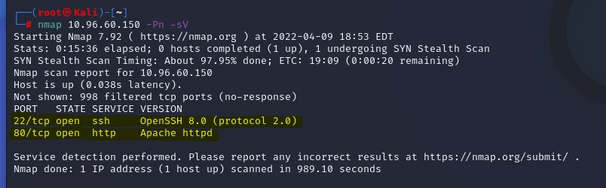

Two ports opened:

* + Port: 22 service: ssh version: openSSH 8.0
  + Port: 80 service: http version: Apache httpd

1. Let scan all the directory held by Apache httpd server using “dirb” tool to target the directory.

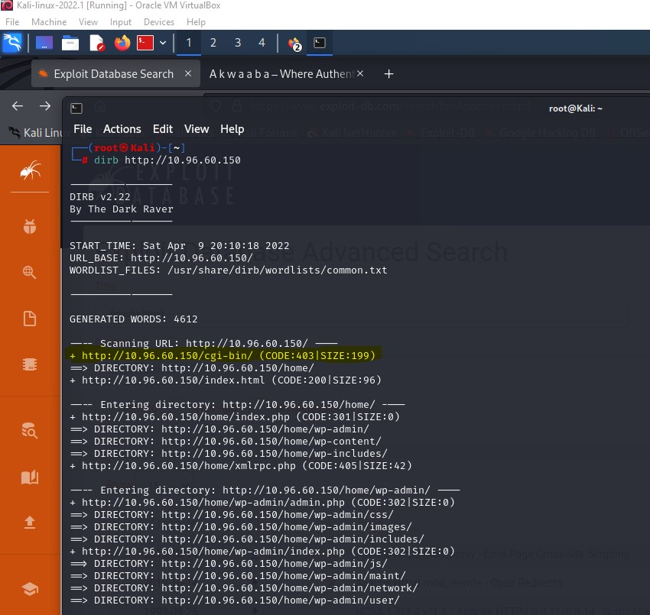

Continuous directory and files scanned of the target

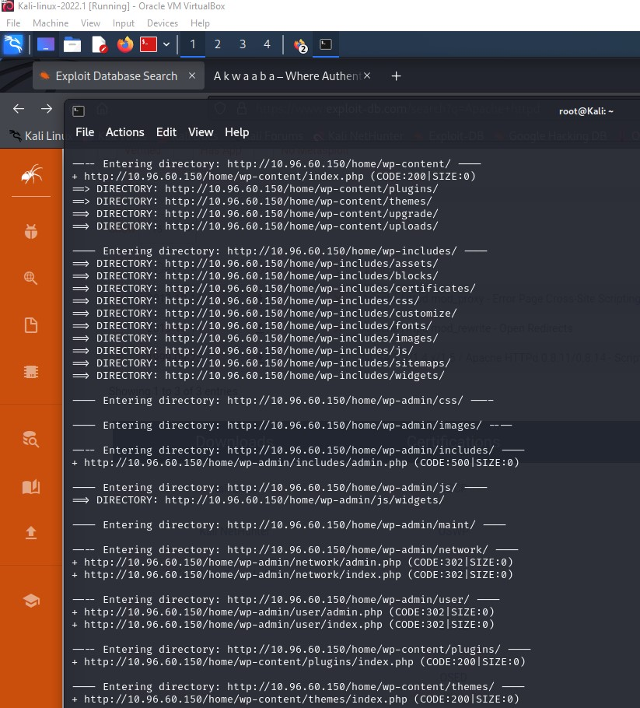

Continuous directory and files scanned of the target

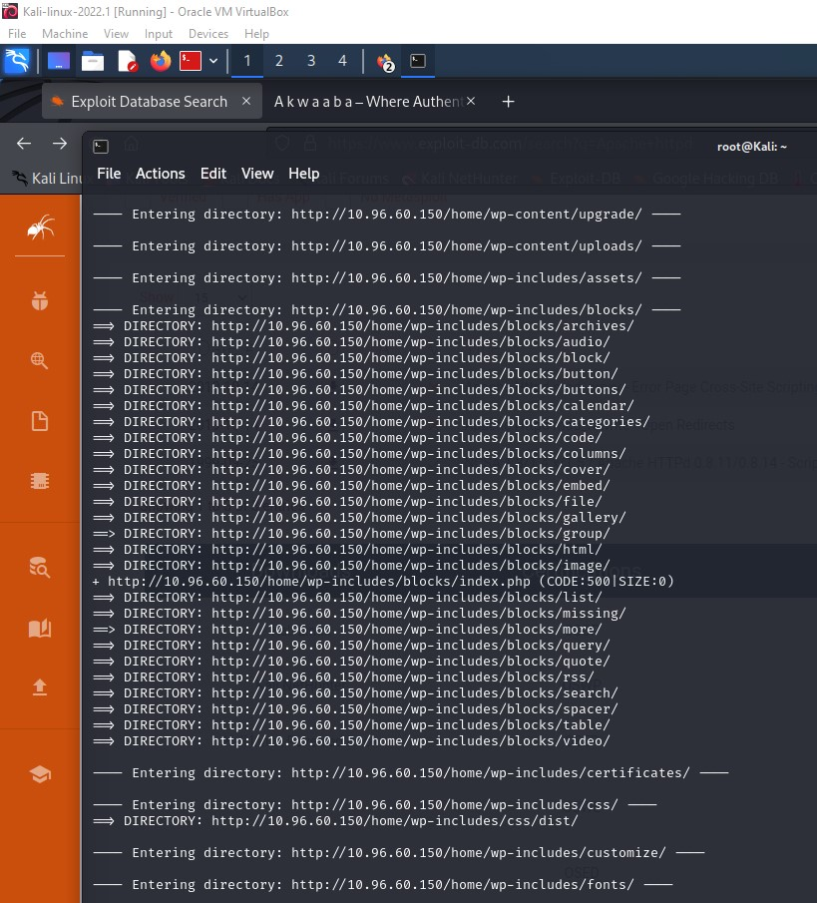

Continuous directory and files scanned of the target

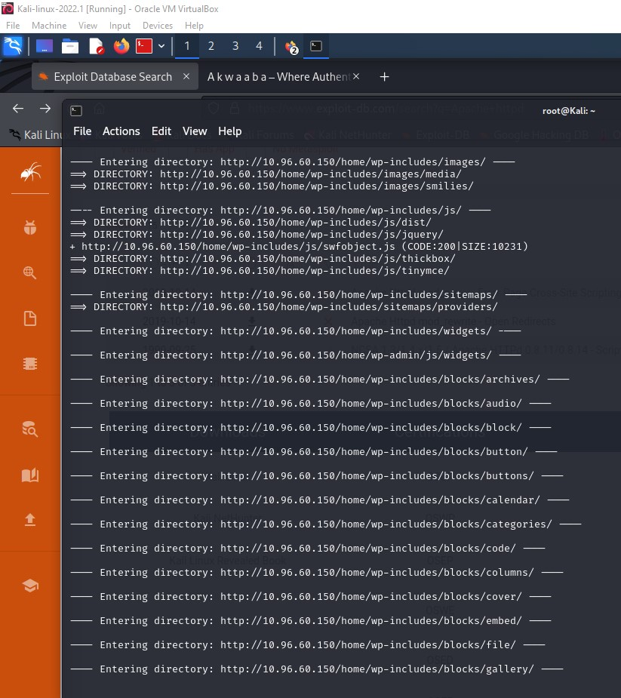

Continuous directory and files scanned of the target

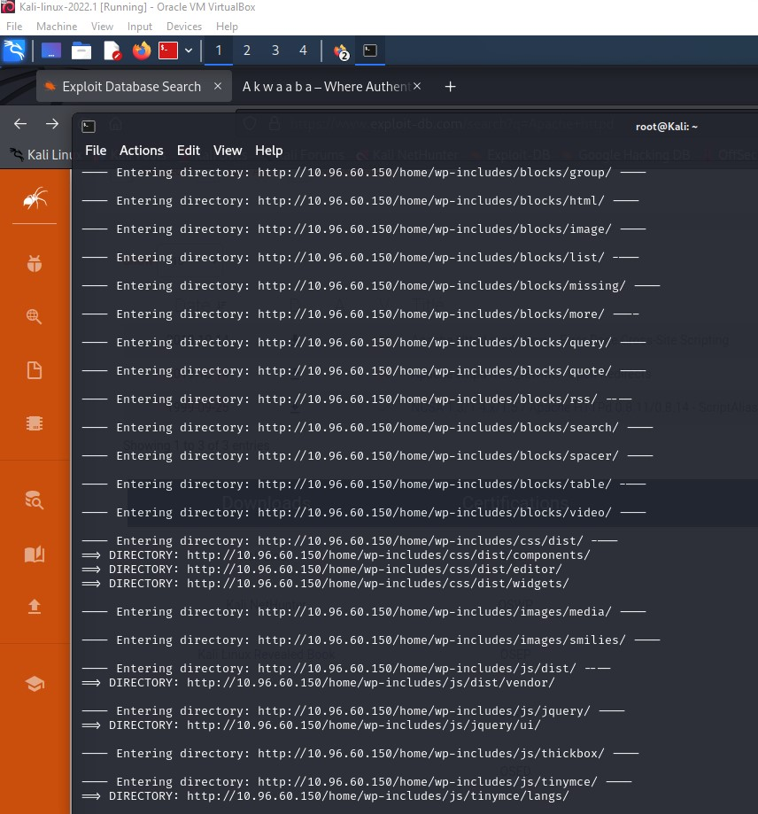

Continuous directory and files scanned of the target

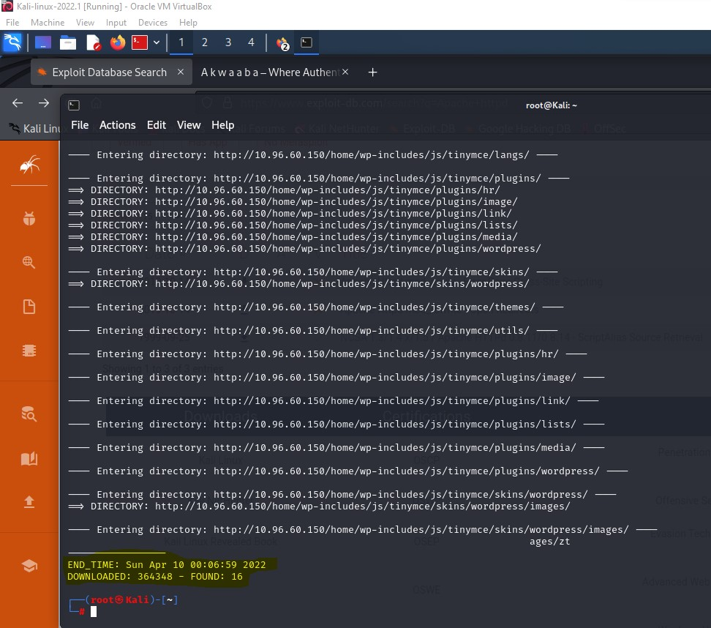

3.) We will target the cgi-bin because most computer server has the common gateway interface that is way the server interacts with the external generate content. We will exploit the cgi-bin content to gain access to system.

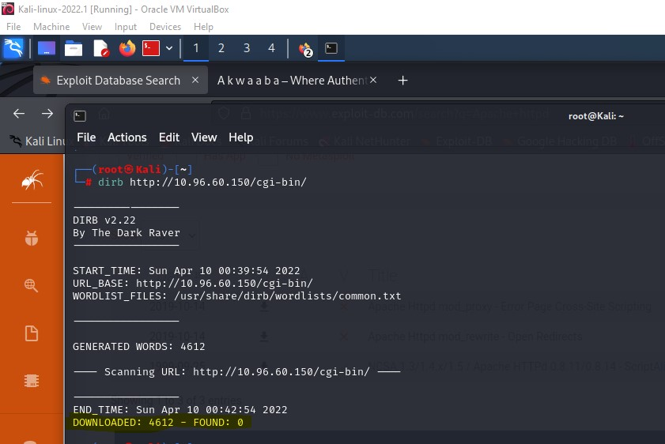

Nothing was found in the cgi-bin. Let exploit